***Program Requirements***

*Versie 1.2.*



*Naam: Aron Dosti*

*Leerlingnummer: 115827*

*Datum: 24/04/2020*

*Table of contents*

1.Introduction 3

2.The company 3

3.Requirements 3

4.Wishes of the Hotelkeeper …………………………………………………………………………………………………………….4

5.Functional demand ………………………………………………………………………………………………………………………..5

6.Technical demand ………………………………………………………………………………………………………………………….5

7.Target of audience 5

8.Design 6

9.Security and Access ........................................................................................................................... 6

10.Information 7

11.Additional 7

# 1.Introduction

I am working for the application and media development department of an IT company. This company is hired to develop a reservation website for Hotel California. In this document there will be explanations about the requirements for making the reservation website and so on.

# 2.The company

The company that hired me is named Hotel California. Hotel California is an international company that is established in the Netherlands. They have opened up in 2017 and are hoping to get more public by letting us make a website for them. Their reviews of customers have also shown a lot of potential for making it international. The demand is to make their reservation website so that customers can book more easily.

# 3.Requirements

* Web Reservation system (a system in which you can make a reservation)
* PHP (and OOP), CSS and HTML (programming language)
* Visual Studio Code (code editor).

# 4.Wishes of the hotelkeeper

The hotelkeeper of Hotel California has a few wishes for the website. He also described the following 4 subsystems of the website and the functionalities therein:

1. Room administration subsystem:
   1. The hotelkeeper must be able to add the category of rooms available in the system.
   2. The hotelkeeper must be able to see a room plan with the location of the rooms.
   3. In the room plan the hotelkeeper must be able to assign the category that the room belongs to.
   4. The hotelkeeper must be able to print a list of rooms and the category they belong to.
2. The pricing Subsystem:
   1. The reservation desk must be able to assign a room price for the one of the 3 categories of rooms (family, single, double rooms) for a period of time or a certain day of the year.  
      The pricing system must be completely filled in, at least 3 months in advance.
   2. The reservation desk must be able retrieve a list of room prices per day. They must be able to print this list.
3. The web reservation system:
   1. Web visitors must be able to see the available categories of rooms and the prices for those categories from a certain start- to an end date. When the prices differ during the period, it is also showed on the website. Per room category the visitor will see some photos on the website and a video in an appropriate web format. The visitor will also see the amount of rooms available per category.
   2. The web visitor must be able to make a reservation. While making the reservation the visitor must be able to enter his name, first name, home address, city, country, telephone number and email address. After entering the reservation the visitor will receive a confirmation email that will include the invoice.
   3. The hotelkeeper must be able to see and print a list of occupied and reserved rooms within a certain period.
4. The front desk system:
   1. The front desk must be able to print a list of room prices for a week.
   2. The front desk must be able to see all unoccupied and the amount of “not reserved” (vacant) rooms on a certain day per category.
   3. The front desk must be able to register a guest as an occupant of a room.
   4. The front desk must be able to see if the room is prepaid or post-paid.
   5. In case of post-paid rooms the front desk must be able to print an invoice for the room rent (fee) that is due.

Further there will be a Database needed and more will be explained in the Functional- and Technical design.

# 5.Functional demand

functional demand basically means describing all the functions that is demanded and offered. The website demands:

- a reservation function

- a checkout function

- a calendar date function

- an availability function

- a saving to the database function.

More will be explained in the Functional design.

# 6.Technical demand

Technical demand means describing the wireframes, tools, designs ,use case, flowchart and ERD.

Wireframes: simple sketches of every page of the website with no color.

Tools: the helper for the designing. tools like Photoshop and draw.io are being used on this website.

Designs: there will be designs of each page of the website with color.

Use case: A use case is a written description of how users will perform tasks on your website. It outlines, from a user's point of view, a system's behavior as it responds to a request. Each use case is represented as a sequence of simple steps, beginning with a user's goal and ending when that goal is fulfilled.

Flowchart: a Flowchart is a schematic performance of the process of a Function or website

ERD: ERD stands for Entity Relationship Diagram and is the sketch or design of the database and it’s relations with the Functions.

More will be explained in the Functional- and Technical design.

# 7.Target of audience

The application/website is of use by the staff and owner of hotel California and the visitors/customers are all allowed to visit.

# 8.Design

At the moment there are no designs or wireframes available and Further designs will be resumed in the Technical- and Functional design. Here are some wireframes of recommendation and inspiration of what it could look like: (credits to: st Giles Hotel).

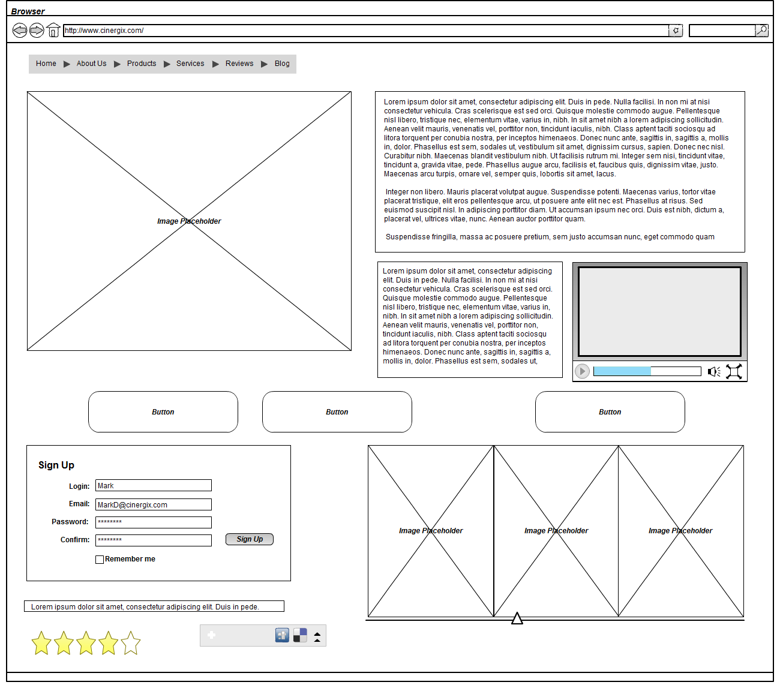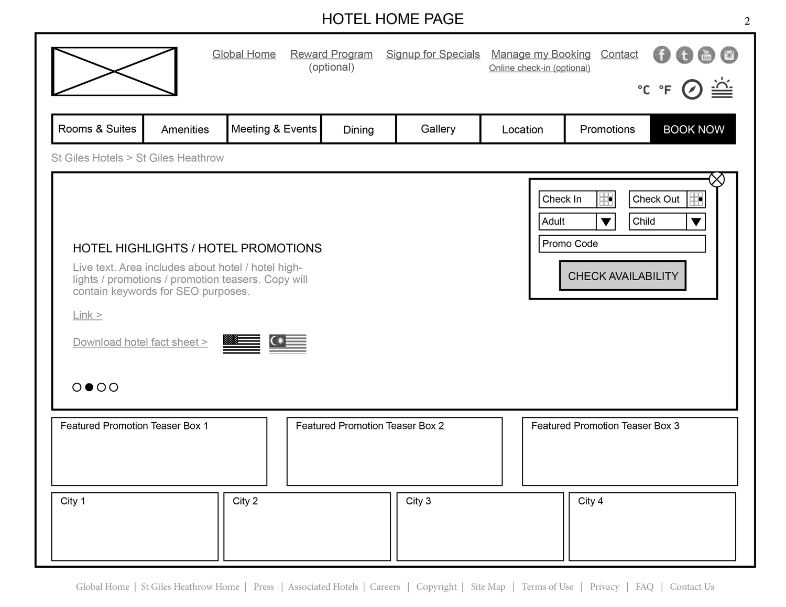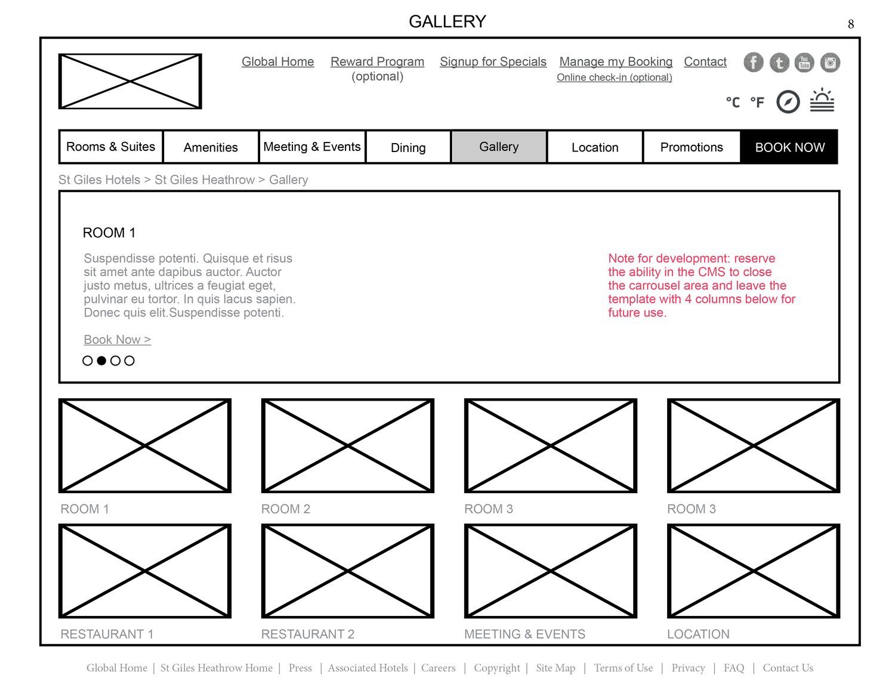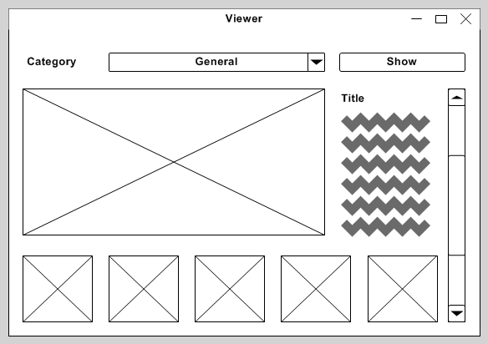

# 9.Security and Access

Currently there is no security but will be coming soon. The database and admin panel must only be accessed by the owners and staff of hotel California and will be possible to be done by adding a encrypted password and making backup for the data. More will be explained on the Functional- and Technical designs.

# 10.Information

For the hosting there will be needed:

**For images:**

* <https://unsplash.com>
* <https://pexels.com>
* <https://pixabay.com>
* Xampp windows for connection to database and website.
* A PHP based Webserver
* Photoshop
* Internet connection.

# 11.Additional

Sources that helped with finding my information:

* <https://www.google.com/search?q=hotel+wireframes&client=firefox-b-d&sxsrf=ALeKk039TdFS-TJU0yIL3EoM3Lso48oD8g:1587737864131&source=lnms&tbm=isch&sa=X&ved=2ahUKEwja5Yy7oIHpAhUF-qQKHV0qCCcQ_AUoAXoECAsQAw&biw=958&bih=960>
* <http://www.thuminhdo.com/st-giles-hotel-website>